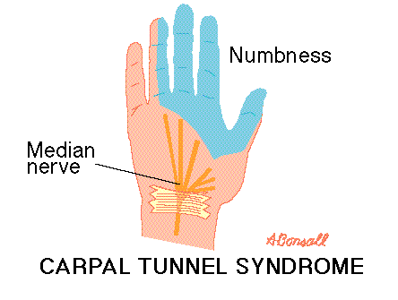
Carpus is a word derived from the Greek word "karpos" which means "wrist." The wrist is surrounded by a band of fibrous tissue which normally functions as a support for the joint. The tight space between this fibrous band and the wrist bone is called the carpal tunnel. The median nerve passes through the carpal tunnel to reach the thumb, index, and middle fingers of the hand. Any condition that causes swelling or a change in position of the tissue within the carpal tunnel can squeeze and irritate the median nerve. Irritation of the median nerve causes tingling and numbness of the thumb, index, and the middle fingers, a condition known as "carpal tunnel syndrome."
Often it is the result of the unnatural strain and repetitive impact of the fingers on the keys that causes carpal tunnel syndrome among computer users… however, with the pseudo-keyboard the hands are freed from this harmful strain therefore reducing the risk of carpal tunnel syndrome!
However, this more natural way of typing can prevent strained necks, backs, and arms… as well as improved typing accuracy by having each finger independent of the other!

